AI Use Declaration Form
Course: Introduction to Artificial Intelligence
Lab Title: Lab 3— Feedforward Neural Networks
Student Name: Lois Vanessa Adams________________________________________________
Student ID: ____69312028__________________________________________________
GitHub Repository Link: https://github.com/loisvanessaadams-create/Adams_Lois_Lab0.git
Date Submitted: __28th July,2026________________________________________________

1. AI Use Summary
Question | Student Response
Did you use any AI tool for this lab? | Yes
Estimated percentage of the work influenced by AI | 15%
Did you attach evidence of AI use where applicable? | yes

2. Details of AI Use
Complete the table below for each AI tool used. Add more rows where necessary.
Name of AI Tool Used | Purpose for Using the Tool | Prompt or Instruction Given to the Tool | Part(s) of the Work Influenced by the Tool | How I Verified, Edited, or Improved the AI Output
ChatGPT | Clarifying PyTorch concepts, understanding how to do neural network training, explaining error messages and assiting with debugging. | Prompts like help me understand how dropout is used in a feedforward network, loss.backward and the likes | Debugging, understanding and helping with how to insert images in markdown files | Mainly used it to get general syntax and see how some commands in PyTorch were created and used  Also I corrected errors and wrote the reflection questions.

An example of how AI was used
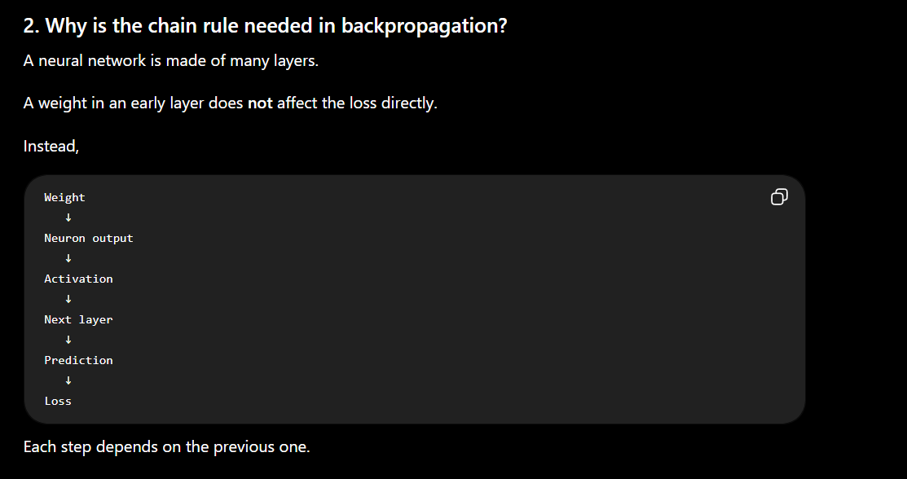
3. Attachment of AI Output Evidence
Where required, attach evidence of AI use. Tick all that apply. Add more rows where necessary.
Evidence Type | Attached? (Yes, No, N/A) | File Name
AI-generated draft | yes
Prompt history | yes
Screenshot of AI interaction | yes
Exported AI conversation | no
AI-generated code snippet | No
Revised version showing student input | no

4. Student Declaration
I declare that:
Declaration Statement | Response (Yes/No)
The submitted work is my own work. | yes
Any use of AI tools has been clearly declared in this form. | yes
The prompts, instructions, and AI-generated outputs have been disclosed where applicable. | yes
I reviewed, tested, edited, and improved any AI-generated content before submission. | yes
My AI usage does not exceed 25% of the entire work. | yes
I understand that undeclared or excessive AI use may be treated as academic misconduct. | yes

Student Signature: ___________LVA________________________________
Date: ______________28th July,2026_____________________________

